**Linear Programming – Assignment 1**

**By Marko Bandzo, ID: 1121089**

**Q1.**

Firstly, we are given three obvious constraints:

x ≥ 0, y ≥ 0, z ≥ 0

This simply means that the company cannot produce a negative number of cars. x, y, and z will be used as variables for A, B, and C class cars respectively.

Secondly, the task is to maximise the profit that the company will make. Therefore, the objective function will take the selling price of each car multiplied by the number of cars made, and the sum of all cars should be maximised, as so:

350x + 450y +550z = P

Now, the first non-trivial constraint is the time taken for each car to be made. x takes 1, y takes 2, and z takes 3 minutes each. The specified number of hours in one work day is 6, therefore the total number of minutes in one day is 6*60 = 360, which means the total time cannot exceed this number. Therefore:

x + 2y + 3z ≤ 360

The second constraint is that the average car has to have a fuel efficiency of at least 18 km/l. The fuel efficiency per car is 20, 17, and 14, therefore the sum of all cars multiplied by 18 has to be LESS than the sum of all cars multiplied by their individual weights, as such:

20x + 17y + 14z ≥ 18(x + y + z) *which simplifies to*

-2x + y + 4z ≤ 0

Now we have all the constraints and the objective functions. The Matlab file provided in the zip uses matrices, vectors, and the linprog function to give a final solution of x = 360, y = 0, and z = 0, which can be verified by running the program ‘Ex1.m’. The program is also commented and explains the reason for each line of code.

**Q2.**

The following graph is used as a reference in the following answers to Q2.

**2a.**

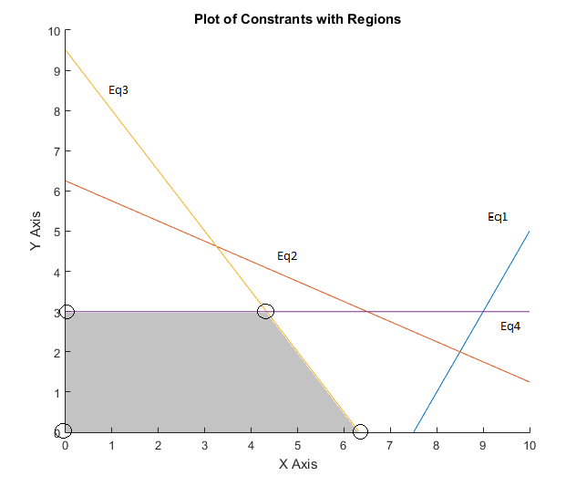

**2b.** The Feasible Region is shaded in 2a.

**2c.** Yes, since it does not stretch to infinity (assuming x ≥ 0 and y ≥ 0 are constraints since we are looking for a maximum)

**2d.** The binding constraints are Eq3 and Eq4 because Eq1 and Eq2 do not change the feasible region. (Eq1 - 4 are in the same order as listed in the question.)

**2e.** Looking at the vertices, it is clear that (0,0) is not the maximum. The two that intersect the x and y lines are (0,3) and (6.33,0). The final vertex is the intersection between Eq3 and Eq4, which is at (4.33,3) (x solved by substituting y = 3 in Eq3). Therefore the maximum is the final vertex, which gives the largest result of x + y at 7.33 recurring.

**2f.** The commented Matlab .m file is provided in this Zip file titled ‘Ex2.m’.

**2g.** The Matlab command ‘.iterations’ shows the number of iterations the algorithm underwent to get to the solution. In this case, the answer was 2. (also included in the .m file)